Fin Cover Ansys Investigation

1. Set-up

Different fin covers were tested using ansys fluent density based solver. Domain was constructed such that it extended 300 mm behind the back edge of the fin, 200 mm in front of the fin, and 125 mm from the other edges. The bottom of the domain wall lines up with the bottom edge of the fin. First to higher order blending was used to attempt to damp out oscillations in the continuity residuals. Automatic refinement was used to refine high pressure gradient cells every 100 iterations. Solutions are converged when continuity residual reach 1 x 10-6.

Shapes tested:

* Bare Fin
* Current Airfoil
* Current Airfoil with some cut off the trailing edge
* Current Airfoil with more cut off the trailing edge
* Current Airfoil with almost all of trailing edge cut off
* Smaller Airfoil that does not cover the entire fin

1. Bare Fin Results

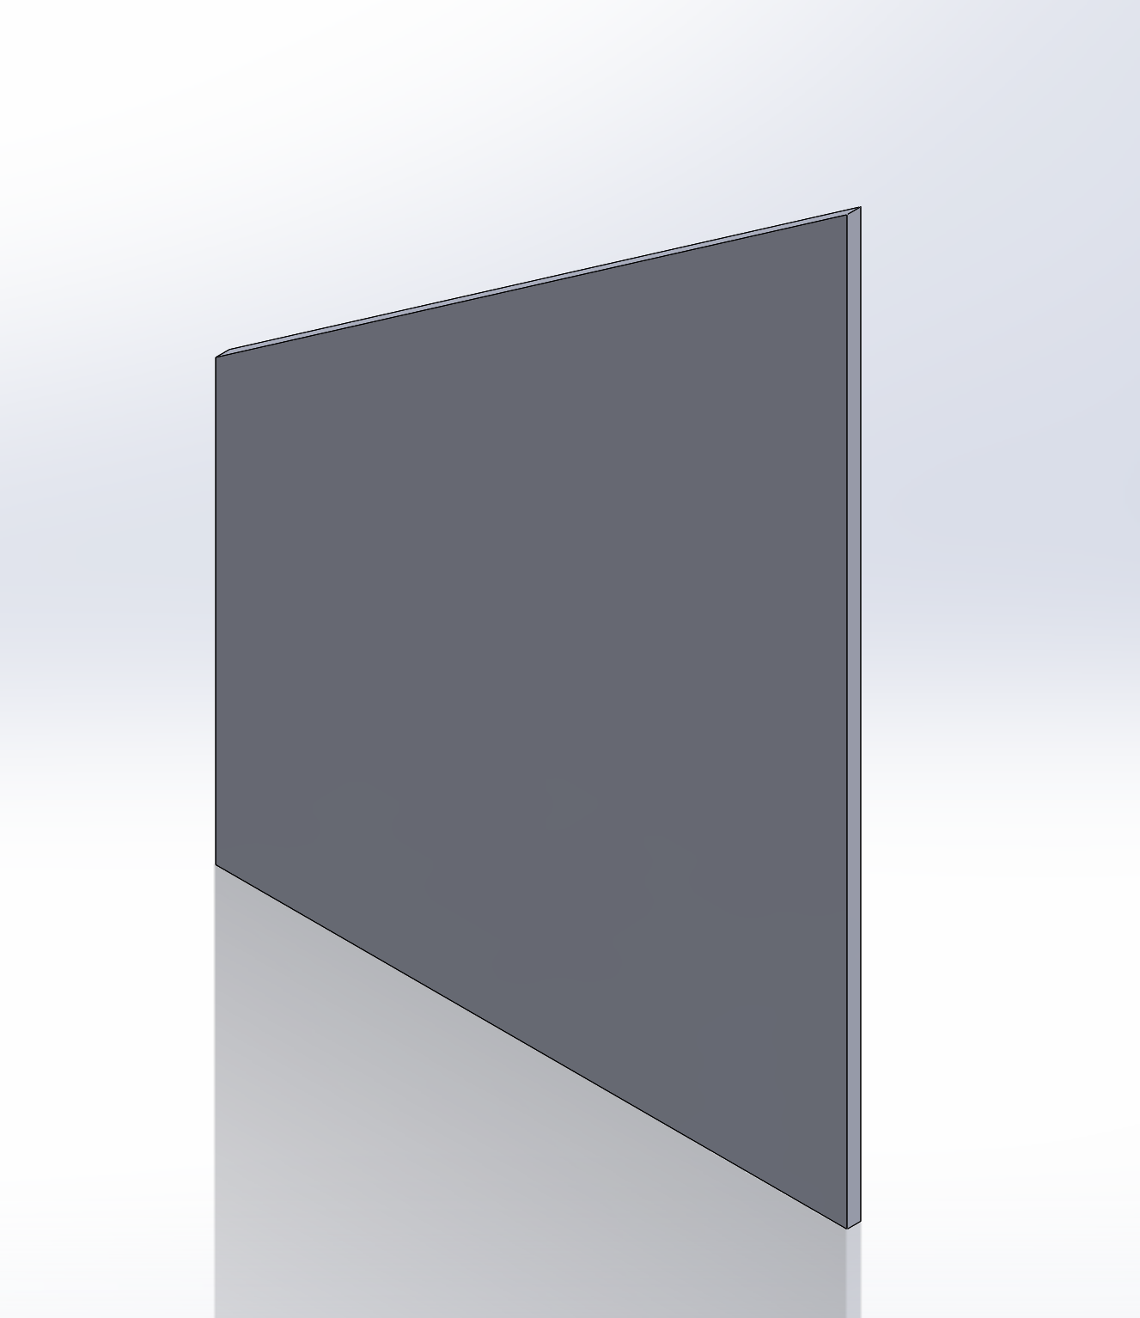

Geometry

Velocity Contour Plot

Drag Force: 5.8805059 N

1. Current Airfoil Results

Geometry

Velocity Contour Plot

Drag Force: 4.1975856 N

1. Current Airfoil Some Cut
2. Current Airfoil More Cut
3. Current Airfoil All Cut
4. Smaller Airfoil

Geometry

Velocity Contour Plot

Drag Force: 4.2829938 N